REMOTE LEARNING POLICY

Version | 1.0
Author | The Key and H Wood
Date Approved by  Governing Body | December 2020
Review Date | December 2021

Contents
- Aims 1
- Roles and responsibilities 1
- Who to contact 4
- Data protection 4
- Safeguarding 5
- Monitoring arrangements 5
- Links with other policies 5
Appendix – Links to professional guidance, advice and support 6

Aims
This Remote Learning Policy aims to:
Ensure consistency in the school’s approach to remote learning
Set out expectations for all members of the school community with regards to remote learning Provide appropriate guidelines for data protection
Please note that this policy has been created with regard to advice and guidance received from Department for Education (DfE) and from Joint Unions (see links in Appendix).

Roles and responsibilities

Teachers
Teachers take responsibility for their classes remote learning. Underpinning this approach is an understanding for flexibility as to when teachers can be available. If they are unable to work for any reason during this time, for example due to sickness or caring for a dependent, they should report this using the normal absence procedure.
Teachers are responsible for:
Setting work:
- Administration staff will send an email to support parents on the first day of absence. From that point onwards, teaching staff will set work that the class completed the previous day.
- Class teachers will provide approximately three activities per day for their pupils plus Reading;
- Activities should include one English (either Writing, reading or Spelling); one Maths; and one other Curriculum subject;
- Instructions should contain enough detail for the pupil to be relatively independent (age dependent). Teachers should not assume that a home has access to a printer to print anything;
- SLT will provide support for home learning and will, at times, ask to see what is being shared and provide guidance where needed.

- SLT will coordinate with teachers to ensure consistency of approach and to try and ensure that pupils with limited access to computers/devices can still complete the work.
Responding as appropriate to parents:
- Teachers will aim to respond to parents within 3 days if they are available;
- Teachers should never use a personal device that shares their personal contact details (e.g. phone number or private email address);
- Parents who send a pupil’s work and/or photographs/videos should receive an acknowledgement and praise from a teacher or other school staff. This will not aim to replicate feedback on strengths and development in learning that parents might expect when the school is open and working normally.
Parents should note that the government does not expect them to perform as teachers nor expect a school’s lockdown offer of remote learning activities to be ‘education as normal but from home’. While it is ideal for children to remain engaged with their learning and particularly rewarding if they can share this with a parent(s)/carer(s), it is recognised that families are all coping in different ways with different challenges and there is therefore no expectation that work will be completed to the standard that teachers would normally expect in class;
- The school communication policy states that all communication should be send through the office at Ringinglow Road or Psalter Lane.
Attending virtual meetings with colleagues:
- Teachers will not however take part in any virtual or online meetings or lessons with pupils or parents. Where appropriate, zoom meetings will be organized at the discretion of the headteacher and assistant headteacher.
Making contact with parents or pupils (usually by phone) as part of the school’s existing planned programme of contact:
- Is as detailed within the school’s Child Protection Policy and remains compliant with the Staff Code of Conduct.

Administration staff

Administration staff are the first port of call for contact from parents and carers. When they have received contact from parents that children will have to self-isolate they will:

Send the first day absence due to Covid email to parents immediately (see appendix)

They will inform SLT of the child’s absence as it is related to Covid 19

They will inform teaching staff so that they are able to prepare learning materials for the following day and throughout the period of absence requiring remote learning.

Keep in touch regularly with the family so that school are aware of any ongoing concerns related to Covid 19.

Support teaching staff with the delivery of remote learning- access to user names, accounts, etc.

Teaching Assistants
Teaching assistants should be available during their normal working hours on the days they are normally required in school. If they are unable to work for any reason during this time, for example due to sickness or caring for a dependent, they should report this using the normal absence procedure.
Teaching assistants may:
Work in school for specific tasks as required by the Headteacher; Undertake remote and/or online CPD training;
Attend virtual meetings with colleagues.

Subject Leads- guided by the Headteacher and Assistant Headteacher
Alongside their teaching responsibilities, as outlined above, Subject Leads may:
Consider whether any aspects of the subject curriculum need to change to accommodate remote learning;
Work with teachers setting the curriculum subject to make sure work set is appropriate and consistent;
Work with other subject leads and senior leaders to make sure work set across subjects is appropriate and consistent, and activities are being set at an appropriate distance away from each other;
Monitor the work set by teachers in their subject – explain how they will do this, such as through regular meetings with teachers or by reviewing work set;
Alert teachers to resources they can use to teach their subject.

Special Educational Needs and Disability Coordinator (SENDCo)
The SENDCo is responsible for coordinating provision for pupils with SEND across the school as set out within the schools Special Educational Needs Policy. During a period of enforced school closure, the SENDCo will continue to:
    - Lead on liaison with SEND pupils at home and their families;
    - Ensure completion of necessary SEND paperwork and/or applications;

Senior Leadership Team (SLT)
Alongside any teaching responsibilities, senior leaders are responsible for:
    - Coordinating the remote learning approach across the school;
    - Monitoring the effectiveness of the remote learning activities for example through contact with teachers and subject leaders and reviewing the work set;
    - Identifying which families may have no access to the internet and ensuring that hard copies of learning activities planned by teachers are made available to the parent for collection or delivery;
    - Oversee the ongoing wellbeing and CPD of teaching assistants.

Designated Safeguarding Lead (DSL)
The DSL’s responsibilities are identified within the school’s Child Protection Policy.

Pupils and parents
Staff can expect pupils to:
- On the first day of absence related to Covid 19- complete the suggested tasks on the email from administration staff.
- Try their best to complete at least some of the activities provided on a daily (weekday) basis; Do some reading (or listen to some reading) every day;
Seek help if they need it from adult(s) at home; Have fun.
Staff can expect parents to:
Support their child(ren) as best they are able given their own home circumstances, health and work commitments etc;
Seek help from the school if they need it;
Be respectful when making any concerns known to staff;
- Confirm that they are happy for their child’s work to be uploaded to the school website or social media, where appropriate.

Governing Body
The Governing Body is responsible, including as advised by the DfE, for: Supporting staff and pupil wellbeing;
Being pragmatic about what is covered in virtual meetings by prioritising urgent, time bound decisions only;
Keeping monitoring to a minimum by focusing on safeguarding, health and safety, headteacher and staff wellbeing and (to a lesser extent) the school’s approach to providing remote learning for pupils;
Directing any approaches by parents made to them directly or indirectly to the school via email to enquiries@cliffordallsaints.sheffield.sch.uk or hbrankin@cliffordallsaints.sheffield.sch.uk;
Determining how to handle statutory procedures during a period of enforced closure such as grievance and disciplinary panels, exclusions, complaints and admission appeals, noting that:
Exclusions – the DfE has clarified that the statutory timeframes for considering exclusions are still in effect but that the regulations already anticipate that these timeframes cannot always be met.
Complaints - the DfE has updated their guidance for school’s complaints policies to provide that new or existing complaints should not be handled whilst schools are closed. If a school is closed during the enforced closure period, the Headteacher should write a response to outline the school’s position and explain that the school is unable to follow its usual complaints process until school has reopened.

Who to contact
If staff have any questions or concerns, they should contact the following individuals:
- Issues in setting work – contact the Headteacher or Assistant Headteacher
- Issues with behaviour – contact the Headteacher or Assistant Headteacher
Issues with IT – Headteacher or Assistant Headteacher and log a job on the ICT Service Desk on the desktop
Issues with their own workload or wellbeing – Headteacher or Assistant Headteacher
- Concerns about data protection –contact Headteacher or Assistant Headteacher
- Concerns about safeguarding – contact the DSL or DDSLs as set out within the school’s Child Protection Policy
If parents have any concerns above and beyond the acknowledgement of work by the class teacher, then they should contact the Headteacher or Assistant Headteacher via: enquiries@cliffordallsaints.sheffield.sch.uk or hbrankin@cliffordallsaints.sheffield.sch.uk;

Data protection

Accessing personal data
When accessing personal data, all staff members will:
Only use their official school email account and never use personal messaging systems;
Connect to the school network using only a school remote desktop connection to work with any personal data to ensure that no data actually leaves the school premises.

Sharing personal data
Staff members are unlikely to need to collect and/or share personal data.
However, if it does become necessary, staff are reminded to collect and/or share as little personal data as possible online.

Keeping devices secure
All staff members will take appropriate steps to ensure their devices remain secure. This includes, but is not limited to:
Keeping the device password-protected – strong passwords are at least 8 characters, with a combination of upper and lower-case letters, numbers and special characters (e.g. asterisk or currency symbol);
Ensuring the hard drive is encrypted – this means if the device is lost or stolen, no one can access the files stored on the hard drive by attaching it to a new device;
Making sure the device locks if left inactive for a period of time; Not sharing the device among family or friends;
Installing antivirus and anti-spyware software;
Keeping operating systems up to date – always install the latest updates.

Safeguarding
The school’s Child Protection Policy is in place and can be viewed on staff share.

Monitoring arrangements
This policy will be reviewed annually by the Headteacher. At every review, it will be approved by the Governing Body.

Links with other policies
This policy is linked to the school’s following policies: Behaviour Policy
Child Protection Policy
Data protection policy and privacy notices ICT and Acceptable Use Policy
Staff Code of Conduct

APPENDIX A- email to parents on the first day of isolation

Home Learning for your child while they are well but isolating at home
Thank you for keeping us in touch and letting us know that …..will be isolating at home from ….dates……

Today activities
Please make sure they spend some time online using some, or all, of the following:
Bug Club, Purple Mash, and TT Rockstars if they are in Y3-5
They should also complete any homework activity already set for them.

Daily during isolation
From tomorrow …….’s teacher will begin setting work for them on Google Classroom for ...to complete at home during the day – as if they were in school.

Each day they are isolating they will be set, at least, three lessons and tasks through Google Classroom. They will be sent work for a lesson in maths, literacy and their class topic.

These lessons and tasks will follow the same work as the children in their class. The class teacher will make sure the materials and work set is suitable for home learning.

We also encourage daily reading with an adult. Attached are some ideas for supporting your child while they are learning at home.

Please let us know as soon as possible if you have any questions or concerns related to the learning set for your child through Google Classroom. That includes any password and user name queries!

Finally, the work is set for children at home who are isolating but well; If your child develops symptoms, or becomes unwell for another reason please let us know.

The Clifford All Saints Team

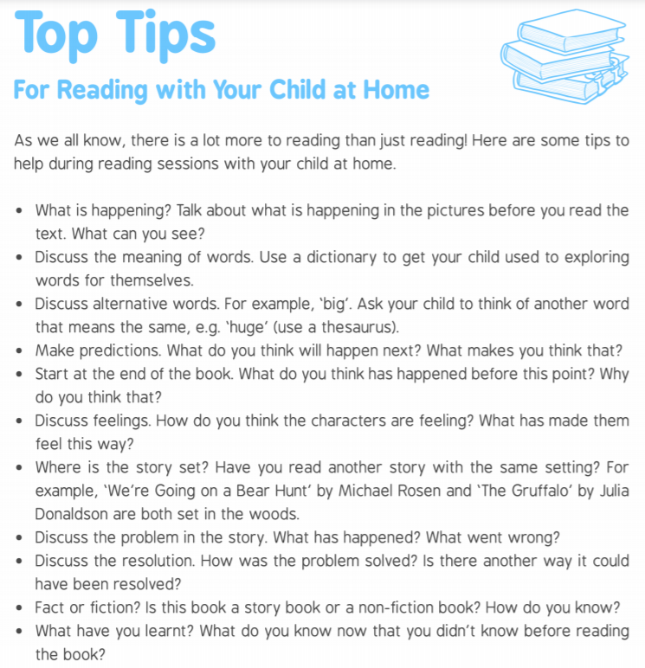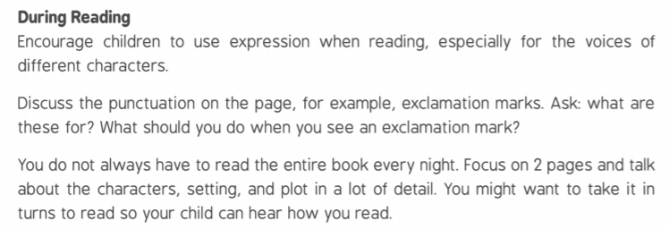

APPENDIX: links to professional guidance, advice and support

Safeguarding and remote education during coronavirus (UK Government)
https:///www.gov.uk/guidance/safeguarding-and-remote-education-during-coronavirus-covid-19

‘There is no expectation that teachers should live stream or provide pre-recorded videos. Schools should consider the approaches that best suit the needs of their pupils and staff’

Joint Union advice on COVID-19 (ASCL, NAHT, NEU)
https://neu.org.uk/media/9826/view

‘We cannot home school the nation’s children’

Coronavirus advice (NEU)
Distance teaching and learning for school leaders https://neu.org.uk/advice/coronavirus-distance-teaching-and-learning-school-leaders

‘A maximum of two to three hours of ‘work’ per day is plenty’

Distance teaching and learning for primary teachers https://neu.org.uk/advice/coronavirus-distance-teaching-and-learning-primary-teachers

‘Teachers should not live stream lessons from their homes, nor engage in any video calling unless in exceptional circumstances, with the parent. Online lessons are not desirable for primary children as the teacher-pupil interaction is not easily replicated’

Undertaking remote teaching safely (NSPCC)

https://learning.nspcc.org.uk/news/2020/march/undertaking-remote-teaching-safely

Safe Remote Learning advice from the PHSE Association
https://learning.naht.org.uk/news-and-opinion/news/curriculum-and-assessment-news/safe-remote-learning- in-pshe-education-advice-from-the-pshe-association

Coronavirus: How do I home school my children (BBC)
https://www.bbc.co.uk/news/ewducation-52314856
Becky Francis, professor at the UCL Institute of Education: ”What is more important, say educationalists, is
maintaining a degree of normality, rather than worrying about a child’s progress in English or Maths. Home schooling for now is about encouraging parents to help their children create regular routines and study
habits’

