YOUR CHILD CAN STILL COME TO SCHOOL IF THEY HAVE:

A cough | A cold | A sore throat | Conjunctivitis | Headlice
 | 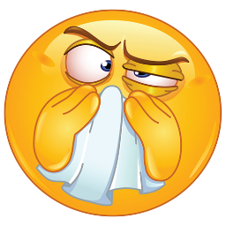 |  | Notify staff | With treatment

Tonsillitis | Hand, Foot & Mouth | Headache | Tired | Tummy ache
 | Notify staff
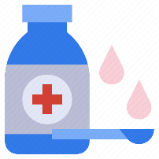 | Prescribed medication and non-prescribed medicine (e.g. Calpol) can be  administered to children, with parental consent.

YOUR CHILD NEEDS TO STAY AT HOME IF THEY HAVE

A temperature | Sickness bug | Diarrhoea | Chicken pox | Impetigo
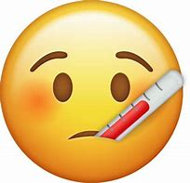  To return to school when controlled by Calpol. | To return to school after 48 hours of last episode. | To return to school after  48 hours of last episode. | To return to school when the spots have crusted over. | 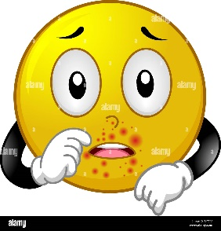  To return to school when sores are crusted and healed or 48 hours after starting antibiotic treatment

REMEMBER!
If your child is too ill to attend school, you MUST let school know as soon as possible.
Please phone: 0114 266 2977
Flu | Slapped cheek | Strep throat
Return to school when recovered/feeling better. | To return to school once the rash has developed. | To return to school 24 hours after starting antibiotics & feeling well enough

