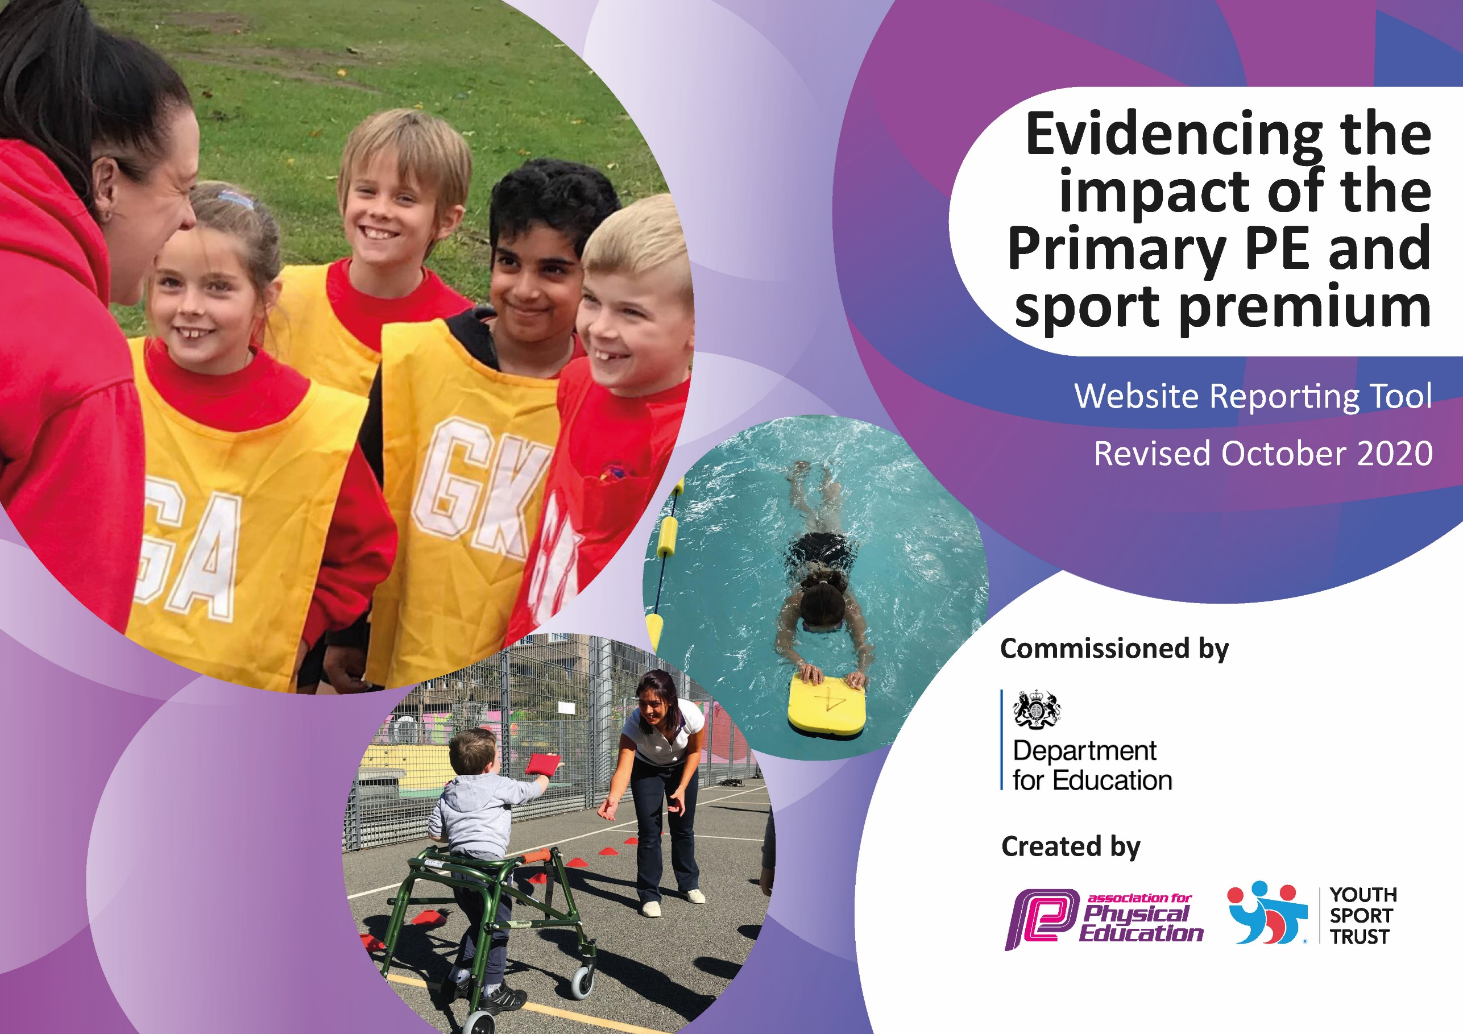
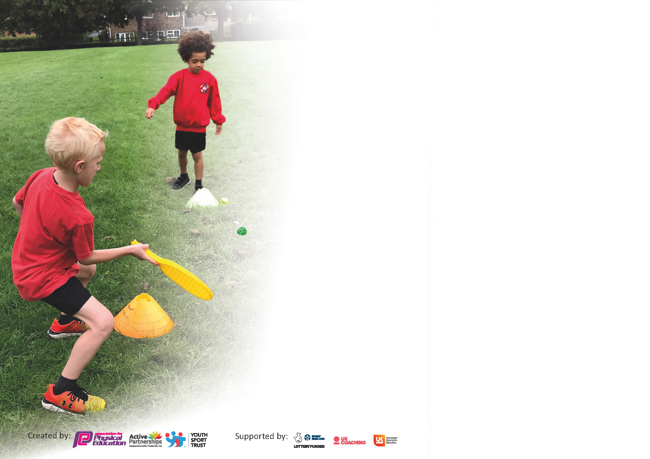

It is important that your grant is used effectively and based on school need. The Education Inspection Framework (Ofsted 2019 p64) makes clear there will be a focus on ‘whether leaders and those responsible for governors all understand their respective roles and perform these in a way that enhances the effectiveness of the school’.

Under the Quality of Education criteria (p41) inspectors consider the extent to which schools can articulate their curriculum (INTENT), construct their curriculum (IMPLEMENTATION) and demonstrate the outcomes which result (IMPACT).

To assist schools with common transferable language this template has been developed to utilise the same three headings which should make your plans easily transferable between working documents.

Schools must use the funding to make additional and sustainable improvements to the quality of Physical Education, School Sport and Physical Activity (PESSPA) they offer. This means that you should use
the Primary PE and sport premium to:

- Develop or add to the PESSPA activities that your school already offer
- Build capacity and capability within the school to ensure that improvements made now will benefit pupils joining the school in future years

Please visit gov.uk for the revised DfE guidance including the 5 key indicators across which schools should demonstrate an improvement. This document will help you to review your
provision and to report your spend. DfE encourages schools to use this template as an effective way of meeting the reporting requirements of the Primary PE and sport premium.

We recommend you start by reflecting on the impact of current provision and reviewing the previous spend.

Schools are required to publish details of how they spend this funding as well as on the impact it has on pupils’ PE and sport participation and attainment by the end of the summer term or by 31st July 2021 at the latest.

** In the case of any under-spend from 2019/20 which has been carried over this must be used and published by 31st March 2021.

We recommend regularly updating the table and publishing it on your website throughout the year. This evidences your ongoing self-evaluation of how you are using the funding to secure maximum, sustainable impact. Final copy must
be posted on your website by the end of the academic year and no later than the 31st July 2021. To see an example of how to complete the table please click HERE.
Created by: Supported by:

Please note: Although there has been considerable disruption in 2020 it is important that you publish details on your website of how you spend the funding - this is a legal requirement.
Support for review and reflection - considering the 5 key indicators from DfE, what development needs are a priority for your setting and your pupils now and why? Use the space below to reflect on previous spend and key achievements and areas for development.

N.B. In this section you should refer to any adjustments you might have made due to Covid-19 and how these will influence further improvement.
Key achievements to date until July 2020: | Areas for further improvement and baseline evidence of need:
From February 2021 the school has been under new leadership. The achievements to date below are reported from previous PE documentation and relate to the management in place prior to February 2021.  From Sport Premium reporting 2019/2020  • Progressive key skills lessons being delivered across all classes  • Dance lessons established in all year groups  • Support for vulnerable pupils and pupils on free school meals to access after school sports provision | Areas identified from last plan 2019/2020  - Expansion into swimming  - Build on Yoga to help with emotional resilience  - Take part in cross country great, for all abilities  - Find a way to support netball  Areas identified by new leadership from February 2021  - Establish and develop a supportive and progressive PE curriculum for all pupils from FS2 to Year 6  - Review KS1 and KS2 facility and resources provision to ensure that any barriers to teaching and learning are removed  - Update all existing PE policies to ensure that they are fit for purpose  - Establish confidence and competencies of teachers with regards to all elements of PE, Sport and Physical Activity  - Provide relevant support, training and mentoring for staff to enhance their subject knowledge and delivery in lessons  - Consider the role of pupil leadership across the school and how PE leaders can be developed

Did you carry forward an underspend from 2019-20 academic year into the current academic year? YES/NO * Delete as applicable

If YES you must complete the following section
If NO, the following section is not applicable to you

If any funding from the academic year 2019/20 has been carried over you MUST complete the following section. Any carried over funding MUST be spent by 31 March 2021.
Academic Year: September 2020 to July 2021 | Total fund carried over: £0 | Date Updated: Jul 2021
What Key indicator(s) are you going to focus on? |  |  |  | Total Carry Over Funding:
 |  |  |  | £0
Intent | Implementation |  | Impact
Your school focus should be clear how you want to impact on your pupils. | Make sure your actions to achieve are linked to your intentions: | Carry over funding allocated: | Evidence of impact: How can you measure the impact on your pupils; you may have focussed on the difference that PE, SS & PA have made to pupils re-engagement with school. What has changed?: | Sustainability and suggested next steps and how does this link with the key indicators on which you are focussing this academic year?:

Meeting national curriculum requirements for swimming and water safety.  N.B Complete this section to your best ability. For example you might have practised safe self-rescue techniques on dry land. | COVID 19- delayed
What percentage of your current Year 6 cohort swim competently, confidently and proficiently over a distance of at least 25 metres?  N.B. Even though your pupils may swim in another year please report on their attainment on leaving primary school at the end of the summer term 2021. | %  COVID 19- delayed until 2021-2022
What percentage of your current Year 6 cohort use a range of strokes effectively [for example, front crawl, backstroke and breaststroke]? | %  COVID 19- delayed until 2021-2022
What percentage of your current Year 6 cohort perform safe self-rescue in different water-based situations? | %  COVID 19- delayed until 2021-2022
Schools can choose to use the Primary PE and sport premium to provide additional provision for swimming but this must be for activity over and above the national curriculum requirements. Have you used it in this way? | Yes/No

Action Plan and Budget Tracking
Capture your intended annual spend against the 5 key indicators. Clarify the success criteria and evidence of impact that you intend to measure to evaluate for pupils today and for the future.

Academic Year: 2020/21 | Total fund allocated: £17160 | Date Updated:31/07/2021
Key indicator 1: The engagement of all pupils in regular physical activity – Chief Medical Officers guidelines recommend that primary school pupils undertake at least 30 minutes of physical activity a day in school |  |  |  | Percentage of total allocation:
 |  |  |  | %
Intent | Implementation |  | Impact
Your school focus should be clear what you want the pupils to know and be able to do and about  what they need to learn and to  consolidate through practice: | Make sure your actions to achieve are linked to your intentions: | Funding allocated: | Evidence of impact: what do pupils now know and what can they now do? What has changed?: | Sustainability and suggested next steps:
Key indicator 2: The profile of PESSPA being raised across the school as a tool for whole school improvement |  |  |  | Percentage of total allocation:
 |  |  |  | %
Intent | Implementation |  | Impact
Your school focus should be clear what you want the pupils to know and be able to do and about  what they need to learn and to  consolidate through practice: | Make sure your actions to achieve are linked to your intentions: | Funding allocated: | Evidence of impact: what do pupils now know and what can they now do? What has changed?: | Sustainability and suggested next steps:
- To ensure that there is a strong base of policy within school that supports good practice within the day-to-day delivery of PESSPA.  - To ensure that all parties involved are aware of the working policies by careful dissemination of the information through a range of media.  - To join Points Learning Network so that the school can stay up-to-date with new initiatives. Local and national guidance. | - PE leads to write a short, medium and long term PE plan to enable some immediate work to take place and to plan for the future development of PE within School.  - All policies, once agreed to be shared with relevant school community via website, PE noticeboard, newsletters.  - Apply for membership of Points Learning Membership. Work with HS to develop plans for this academic year and to drive forward PE within Clifford AS. | Time for PE lead = £? | - Teachers, pupils and parents are clear about what is expected within PE lessons, in terms of curriculum content, kit and participation expectations.

Key indicator 3: Increased confidence, knowledge and skills of all staff in teaching PE and sport |  |  |  | Percentage of total allocation:
 |  |  |  | %
Intent | Implementation |  | Impact
Your school focus should be clear | Make sure your actions to | Funding | Evidence of impact: what do | Sustainability and suggested
what you want the pupils to know | achieve are linked to your | allocated: | pupils now know and what | next steps:
and be able to do and about | intentions: |  | can they now do? What has
what they need to learn and to |  |  | changed?:
consolidate through practice:
- To ensure that all teachers in school are confident and skilled in teaching the breadth of the PE curriculum. This will be done by initially ascertaining current confidence levels and providing support for all staff to enable delivery to successfully take place.  - To establish useable curriculum resources within school to enable effective delivery and to remove the barriers to teaching certain aspects of PE.  - To provide each teacher with a clear curriculum map that is progressive through the key stages and support teaching and learning. | - Carry out a subject knowledge audit to ascertain a baseline of current confidence levels amongst staff. Provide supportive CPD (type to be decided) to enable all staff to gain confidence in delivering PE, Sport and Physical Activity.  .  - Put in place curriculum resources to support all teacher in confidence- Get Set 4 PE  - Construct a curriculum map from KS1 to KS2. The map shows a clear progression of skills through a broad range of activities. Each year builds on the previous one to support progress effectively. | Audit – Time  CPD  £200  Get Set 4 PE Annual Subscription £550  Get Set 4 PE Annual Subscription £550 | - Teachers feel supported and indicate that they feel more confident when delivering areas originally identified as requiring support. After initial support staff are growing in confidence  - Teachers are clear about the content that they are supposed to deliver within lessons. Teachers feel more confident as they have a clear lesson plan to follow. Teachers are clear about the progression that they should see within lessons. Pupils are engaged in lessons and can be seen to be making clear progress.  - There is a clear curriculum map from KS1 to KS2. The map links to the units of work allowing children a clear pathway through the national curriculum enabling national curriculum expectations to be met by the end of KS2. | Continue development of CPD cycle throughout the coming academic year to help develop teacher confidence.  Continue development of CPD cycle throughout the coming academic year to help develop teacher confidence.  Continue development of CPD cycle throughout the coming academic year to help develop teacher confidence.
Key indicator 4: Broader experience of a range of sports and activities offered to all pupils |  |  |  | Percentage of total allocation:
 |  |  |  | %
Intent | Implementation |  | Impact
Your school focus should be clear | Make sure your actions to | Funding | Evidence of impact: what do | Sustainability and suggested
what you want the pupils to know | achieve are linked to your | allocated: | pupils now know and what | next steps:
and be able to do and about | intentions: |  | can they now do? What has
what they need to learn and to |  |  | changed?:
consolidate through practice:
Additional achievements:  - The curriculum map will ensure that children within the school are receiving a broad range of activities within the curriculum. This can be built upon once effectively established. To enable this to happen the schools must make sure that suitable resources and equipment are available and regularly monitored to remove any barriers to teaching and learning.  - In line with the new policy for PE, it is intended to have a system in place to ensure that any damaged / old equipment is routinely removed from circulation to ensure that all equipment is fit for purpose. This will enhance the learning experience for all children.  - It is intended to conduct a review of all aspects of the playing areas used by children for PE, Sport and Physical activity to ensure that the spaces are maximised and fit for purpose. Some consideration of the KS2 yard will be required to try to create an area that is stimulating and more demanding for older children. Consideration of the dual use of the space for both play time and lesson time to ensure that it is functional for both. | - Audit carried out and purchase of necessary equipment, particularly with upper KS2 in mind. Ensure that the equipment enables all children to access the lessons planned. Where SEBD children require modifications ensure that equipment alternatives are sourced.  - Ensure that there is an agreed and publicised system for the removal of any unsafe or damaged equipment (ongoing) as well as regular checks on the equipment.  - Consider how the KS2 yard can be adapted to support learning both in lessons and at playtimes. Meet with Helen Stevens to discuss options. Conider SP budget and other potential sources of income to draw up a wish list. (Meeting date Tuesday 9th February 2021) Will consider carrying out a before and after survey with the pupils at the school. | Purchase of new equipment following audit:  £6000  Training for teachers- Dance  Access to active play equipment KS1 £750  As above  £1000  Fun and active playground- markings and equipment  £7500 | - All necessary equipment has been purchased to support all children within school and to enable all planned curriculum lessons to take place without unnecessary barriers in place.  - A recent survey carried out amongst staff suggested that barriers to learning had been removed through good quality and plentiful equipment.  - The playing area created provides a useable and functional space for both outdoor play and PE lessons. Children with a range of interests consider that is an inviting space and a place that they are happy to be in. | - Continue training for all staff to increase subject knowledge and confidence

Key indicator 5: Increased participation in competitive sport |  |  |  | Percentage of total allocation:
 |  |  |  | %
Intent | Implementation |  | Impact
Your school focus should be clear | Make sure your actions to | Funding | Evidence of impact: what do | Sustainability and suggested
what you want the pupils to know | achieve are linked to your | allocated: | pupils now know and what | next steps:
and be able to do and about | intentions: |  | can they now do? What has
what they need to learn and to |  |  | changed?:
consolidate through practice:
It is important to build on the limited existing provision that has been taking place at Clifford AS. In the past the school has taken part in the X-country competitions and run a Rugger Eds club after school. Continue to sign up to SFSS to enable participation in X-country. Consider other priority areas for participation in competitive sport. | We will consider an intra-school competition as a simple way of starting to get children competitive within school. A ‘Challenge of the Week’ might be considered to engage pupils whilst they are still at home. | Access to Points network- £800  Curriculum leader time: £800  RuggerEds lunch club- £1000 | Initial stages of implementation to support all children in becoming more involved in sport competition and activities | Further support required in involvement in intra school sport as this becomes more available following end of lock downs.

Signed off by
Head Teacher: | C Rowland
Date: | 30.7.21
Subject Leader: | H Wood
Date: | 30. 7.21
Governor: | IEB
Date:

