Clifford All Saints C of E Primary School Writing Progression

Intent
In all we do at Clifford All Saints Primary School, we are inspired by John 10:10; “life in all its fullness”. We aim to provide our children with a rich, full curriculum which allows them the opportunities to enjoy all reading and writing has to offer. We look to provide our children with reading experiences that directly feed into their writing through high quality texts that are the focus of every piece of block of learning. We aim to create a positive reading and writing culture in school, where both are promoted, enjoyed and considered ‘a pleasure’ for all pupils
By the end of Year Six we intend our children to have developed a love of writing and to be able to express their thoughts and ideas clearly and creatively through the written word. We also intend to create writers who can re-read, edit and improve their own writing, and enable pupils to be able to confidently use the essential skills of grammar, punctuation and spelling. We also want our children to have pride in their work and support them to develop a neat, confident, joined handwriting style. Our children are taught to write for a wide range of genres so that they develop an awareness of their audience therefore which also strengthens their abilities in speaking and listening.
Implementation
At Clifford All Saints, to help us to develop confident, enthusiastic writers who can express themselves in a variety of genres and context, our writing lessons are always linked to a high quality shared text.
We use the following process outlined below to support the planning and teaching of writing. To support our writing skills progression, we have looked at the National Curriculum and Pie Corbett’s Talk for writing approach. Every year group has an outline for their taught curriculum that shows where skills from previous years have been consolidated.
We follow the Letters and Sounds approach to teach phonics through the Big Cat Phonics books. Please see our Reading Curriculum Statement for more information on this approach. Early writing is taught through early mark making, then when the children begin Letters and Sounds phonics, they are taught the correct letter formations. This begins with writing (whether with a writing tool or in the air) cvc words, moving onto short sentences using the sounds they have been taught. EYFS children are encouraged to write independently during continuous provision. We use the same phonics program across the school providing continuity and a vehicle for guaranteed progression.
Spelling is an important skill both in and out of school. Spelling rules are explicitly taught in the classrooms as part of dictated sentences and through modelled and shared writing. There is an expectation that children will spend time at home learning their spellings. Spelling is taught daily in Key Stage 1, in Phonics lessons, and weekly in key Stage 2. Children who need additional support with spelling receive a variety of interventions that are tailored to address their gaps.
There is an expectation that grammar will be modelled and used correctly by all teachers. Within our writing skills progression, specific grammar objectives that will be taught in each year group are identified. We aim to ensure children see grammar and punctuation as part of the bigger picture of writing. Sometimes grammar and punctuation skills are taught discretely.
Around the school, there are displays of writing to encourage pride in work, give a purpose and audience and to show that work is valued. We use the Letter Join handwriting scheme and expect that children are maintain the same standard of writing across all subjects.
Impact
The aim of all at Clifford All Saints is that children will make good progress from their own personal starting points. By the end of Year Six, we aim for the children to be able to write clearly and accurately and adapt their language and style in and for a range of contexts, purposes and audiences. Our children will acquire a wide vocabulary and have a strong command of the written word. Most importantly, they will develop a love of writing and reading and be well equipped for the rest of their education.

Writing assessment is ongoing throughout every lesson and cross curricular lesson to help teachers with their planning, lesson activities, targeted pupil support and enable appropriate challenge for all children. Pupils are given feedback and next steps in order to personalise learning and provide the children with opportunities to edit and improve their own writing. Feedback may be written or verbal. Success Criteria are used throughout the writing process to support children to write and assess.
Teachers moderate pupils work in school and with other schools to ensure accurate assessments are made. The quality of writing in English and curriculum books is evaluated by learning walks, drop ins, pupil conferencing and work scrutinies. These inform future areas for improvement and the impact of new initiatives. The English subject leader provides an action plan for the subject and addresses areas for development and improvement which is then shared with all staff.
We track the progress our children are making across our curriculum using PITA (Point In Time Assessment) judgements. They provide an ‘overview’ statement relating to an individual’s learning journey in relation to the writing objective being taught.
Ongoing assessment measures what the children have been taught so far in line with curriculum expectations and coverage. Our ongoing aim is to increase the percentage of children who meet age related expectations.
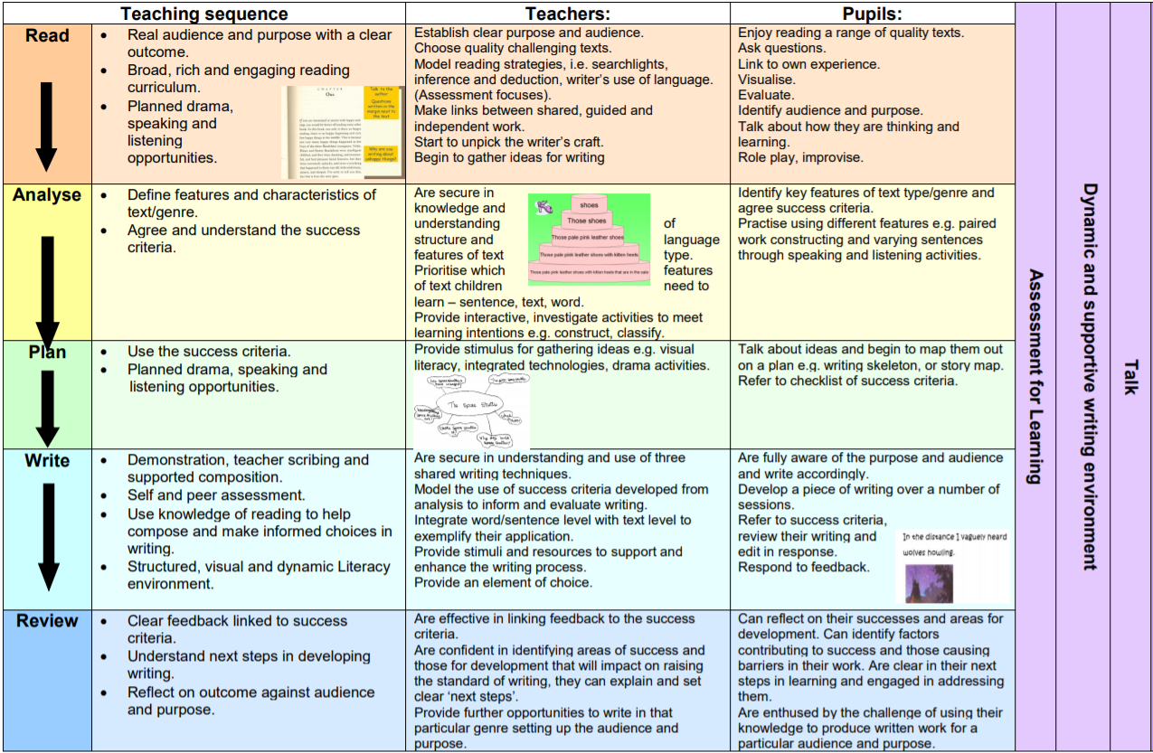

Teaching a range of text types:

In our writing curriculum we recognise the importance of teaching children the features of a range of text types so they are able to use high quality examples to write their own at an age appropriate level. In Key stage 1, children will be exposed to a range of texts but they may not be a part of their written work.
Fiction | Non- Fiction | Poetry
Adventure  Mystery  Science  Fiction  Fantasy  Historical fiction  Contemporary fiction  Dilemma Stories  Dialogue,  Play scripts,  Film narratives  Myths  Legends  Fairy tales  Fables  Traditional tales | Discussion texts  Explanatory texts  Instructional texts  Persuasion texts  Non-chronological reports  Recounts | Free verse  Visual poems  Structured poems

For support in identifying and sharing the full range of text types please see this information from the National Literacy Trust:
https://www.thomastallisschool.com/uploads/2/2/8/7/2287089/guide_to_text_types_final-1.pdf

Reception
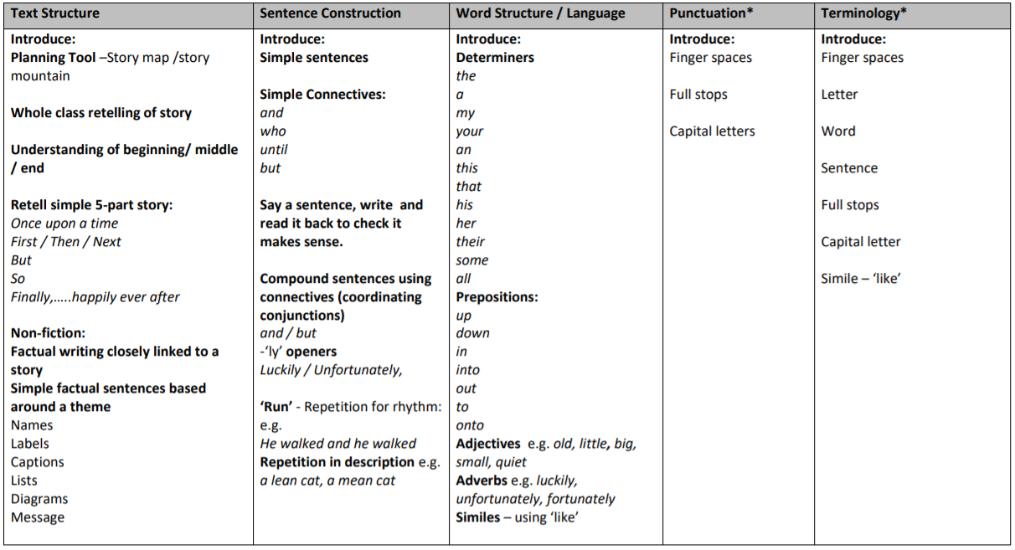

Year 1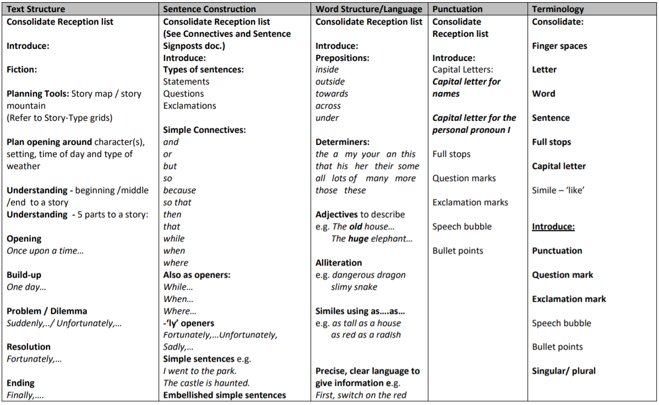
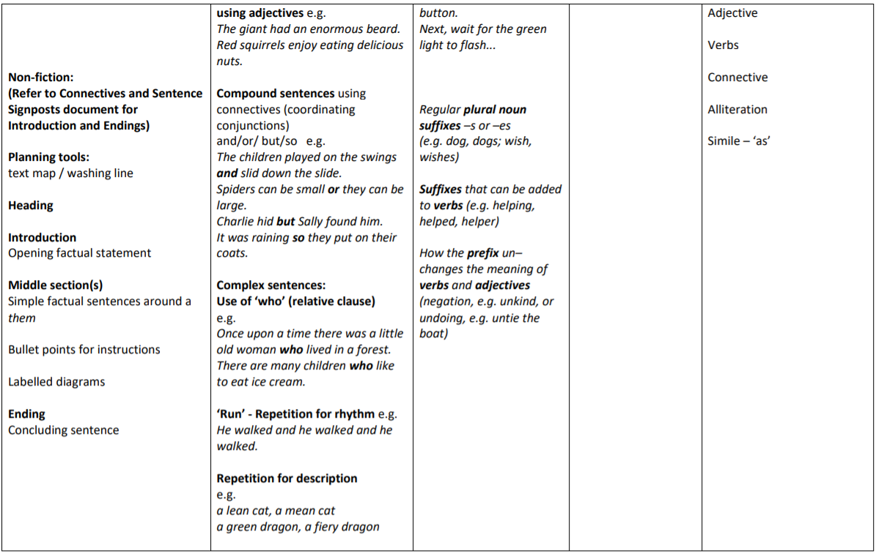

(Band 6 in the Birmingham language and literacy toolkit)
End of Year 1 Non-Statutory Assessment – WTS
Name: | A | B | C | D | E | F | Collection
The pupil can:
- After discussion with the teacher, write simple sentences which can be read by self and others.
- Use present and past tense mainly correctly and consistently in speech
- Some correct use present and past tense in writing.
- Some awareness of the use of full stops and capital letters.
- Spell irregular words (I, no go, into ,the, to) mostly correctly and some Y1 common exception words.
- Segment simple spoken words into phonemes and write the graphemes corresponding to those phonemes. (CVC (fox), CCVC (frog), CVCC (dogs))
- Form many lower-case letters in the correct direction, starting and finishing in the right place..
- Beginning to use spacing between words that reflects the size of the letters.

(Band 7-8 in the Birmingham language and literacy toolkit)
End of Year 1 Non-Statutory Assessment – ‘Y2 Ready’
Name: | A | B | C | D | E | F | Collection
The pupil can:
- After discussion with the teacher, write sentences that are sequenced to form a short narrative (real or fictional)
- After discussion with the teacher, write sentences about real events.
- Use co-ordinating conjunction ’and’ to join some main clauses.
- Use present and past tense mainly correctly and consistently
- Demarcate some sentences in writing with capital letters and full stops. Some correct use of question marks when required.
- Spell many Y1 common exception words and some Y2 common exception words
- Segment spoken words into phonemes and represent these by taught (phase 5) graphemes, spelling some of these words correctly and making phonically-plausible attempts at others.
- Form lower-case letters in the correct direction, starting and finishing in the right place.
- Form lower-case letters of the correct size relative to one another in some writing.
- Use spacing between words that mainly reflects the size of the letters

(Band 8 in the Birmingham language and literacy toolkit)
End of Year 1 Non-Statutory Assessment – GD
Name: | A | B | C | D | E | F | Collection
The pupil can:
- Through discussion with the teacher, recognise that writing has many purposes and begin to identify what these are.
- After discussion with the teacher, write sentences that reflect some of these different purposes.
- Demarcate most sentences in writing with capital letters, full stops and use question marks correctly when required.
- Add Y1 taught suffixes to spell most words correctly in writing

Year 2
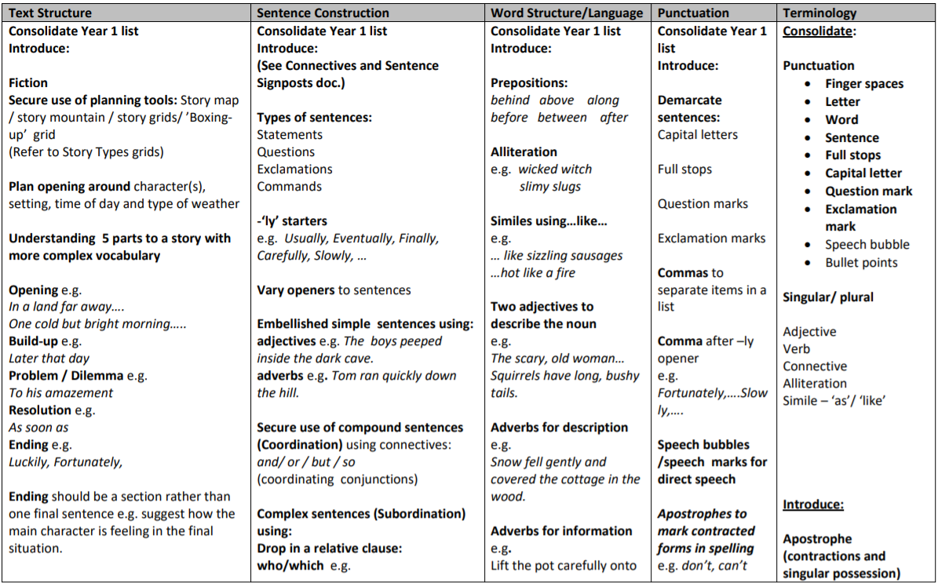
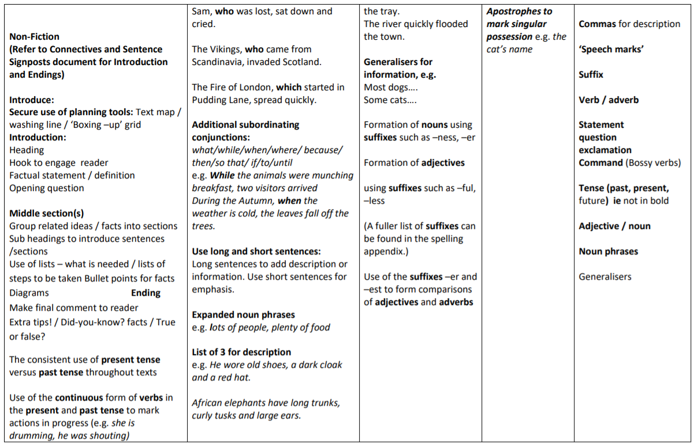

(Band 9-10 in the Birmingham language and literacy toolkit)
End of key stage 1 statutory assessment – working towards the expected standard
Name: | A | B | C | D | E | F | Collection
The pupil can, after discussion with the teacher:
- write sentences that are sequenced to form a short narrative (real or fictional)
- demarcate some sentences with capital letters and full stops
- segment spoken words into phonemes and represent these by graphemes, spelling some words correctly and making phonically-plausible attempts at others
- spell some common exception words
- form lower-case letters in the correct direction, starting and finishing in the right place
- form lower-case letters of the correct size relative to one another in some of their writing
- use spacing between words

(Band 10-11 in the Birmingham language and literacy toolkit)
End of key stage 1 statutory assessment – working at the expected standard
Name: | A | B | C | D | E | F | Collection
The pupil can, after discussion with the teacher:
- write simple, coherent narratives about personal
experiences and those of others (real or fictional)
- write about real events, recording these simply and
clearly
- demarcate most sentences in their writing with capital letters and full stops, and use question marks
correctly when required
- use present and past tense mostly correctly and
consistently
- use co-ordination (e.g. or / and / but) and some
subordination (e.g. when / if / that / because) to join clauses
- segment spoken words into phonemes and represent these by graphemes, spelling many of these words correctly and making phonically-plausible attempts
at others
- spell many common exception words
- form capitals letters and digits of the correct size, orientation and relationship to one another and to
lower-case letters
- use spacing between words that reflect the size of
the letters

(Band 11 in the Birmingham language and literacy toolkit)
End of key stage 1 statutory assessment – working at greater depth within the expected standard
Name: | A | B | C | D | E | F | Collection
The pupil can, after discussion with the teacher:
- write effectively and coherently for different purposes, drawing on their reading to inform the vocabulary and grammar of their writing
- make simple additions, revision and proof-reading corrections to their own writing
- use the punctuation taught at key stage 1 mostly correctly
- spell most common exception words
- add suffixes to spell most words correctly in their writing (e.g. –ment, -ness, -ful, -less, -ly)
- use the diagonal and horizontal strokes needed to join some letters

Year 3
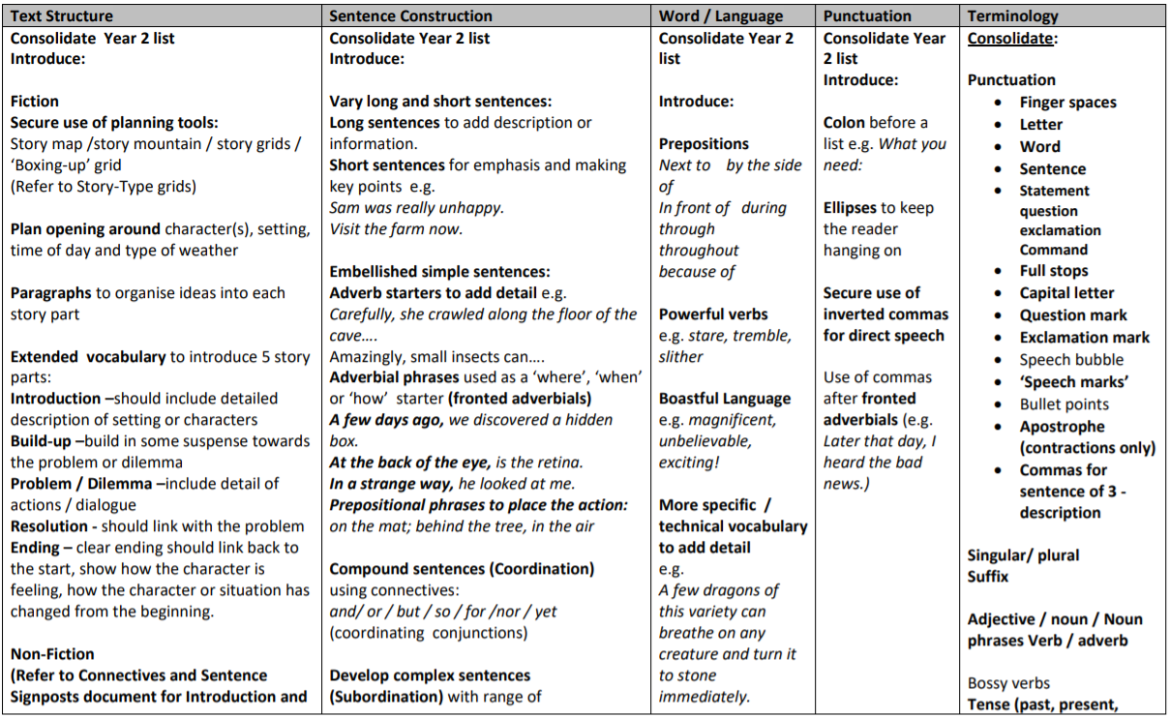
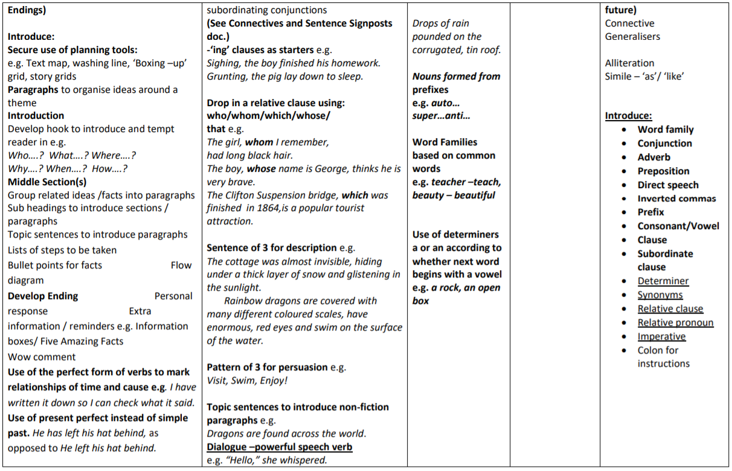

End of Year 3 Non-Statutory Assessment – WTS
Name: | A | B | C | D | E | F | Collection
The pupil can:
- The pupil can, after discussion with the teacher or through scaffolding, write sentences that are linked thematically, with meaning and purpose.
- Some features of writing are appropriate to the selected task.
- Simple adjectives used appropriately to describe.
- Some evidence of use of speech in narratives.
- Some attempt to organise and group related ideas together.
- Use co-ordination (e.g. or/and/but) and some subordination (e.g. when/if/that/because) to join clauses.
- Use present and past tense mostly correctly and consistently.
- Demarcate most sentences in writing with capital letters and full stops, and use question marks correctly when required.
- Spell many common exception words.
- Segment spoken words into phonemes and represent these by graphemes, spelling many of these words correctly and making phonically-plausible attempts at others.
- Spell correctly some words from the year 3 / year 4 spelling list.
- Form capital letters and digits of the correct size, orientation and relationship to each other and to lower-case letters.
- Use spacing between words that reflects the size of the letters.
- Use the diagonal and horizontal strokes needed to join some letters.
(Band 11-12 in the Birmingham language and literacy toolkit)

(Band 12 in the Birmingham language and literacy toolkit)
End of Year 3 Non-Statutory Assessment – ‘Y4 Ready’
Name: | A | B | C | D | E | F | Collection
The pupil can:
- After discussion with the teacher, write for different purposes.
- Features of writing mainly appropriate to the selected task.
- In narratives, describe settings and characters.
- Some use of expanded noun phrases to describe adding relevant and meaningful detail.
- Some evidence of adjectives being used for precision, clarity and impact.
- In narratives, some appropriate use of speech to convey character.
- Some use of simple adverbials and pronouns to link sentences, sections or paragraphs.
- Variation of sentence structure through use of sentences with more than one clause.
- Some use of subordinating and co-ordinating conjunctions to join sentences with more than one clause (eg and, but, so, or, because, when, if.
- Tense choice mostly consistent and grammatically accurate including use of present perfect tense where appropriate.
- Capital letters and full stops consistently used accurately.
- Some correct use of inverted commas.
- Commas used correctly in lists.
- Apostrophes for singular possession used mostly correctly.
- Spelling KS1 common exception words correctly.
- Spelling many words correctly* (year 3/4).
- Letters are consistent in size and proportion with both letters and words evenly spaced.
- Letters are joined using diagonal and horizontal strokes where appropriate.

(Band 12 in the Birmingham language and literacy toolkit)
End of Year 3 Non-Statutory Assessment - GD
Name: |  | A | B | C | D | E | F | Collection
The pupil can:
- The pupil can write effectively and coherently for a range of purposes, drawing on their reading to inform the vocabulary and grammar of their writing
- The pupil can recognise and talk about the audience of a particular text, drawing on some of its language features/vocabulary to inform thinking.
- In discussion with teacher, show an awareness of audience and purpose through formal/ informal language choices.
- Use the range of punctuation taught, correctly. | Full stops
 | Capital letters
 | Question marks
 | Exclamation marks
 | Apostrophes for singular possession
 | Commas in a list
 | Inverted commas to punctuate speech

Year 4
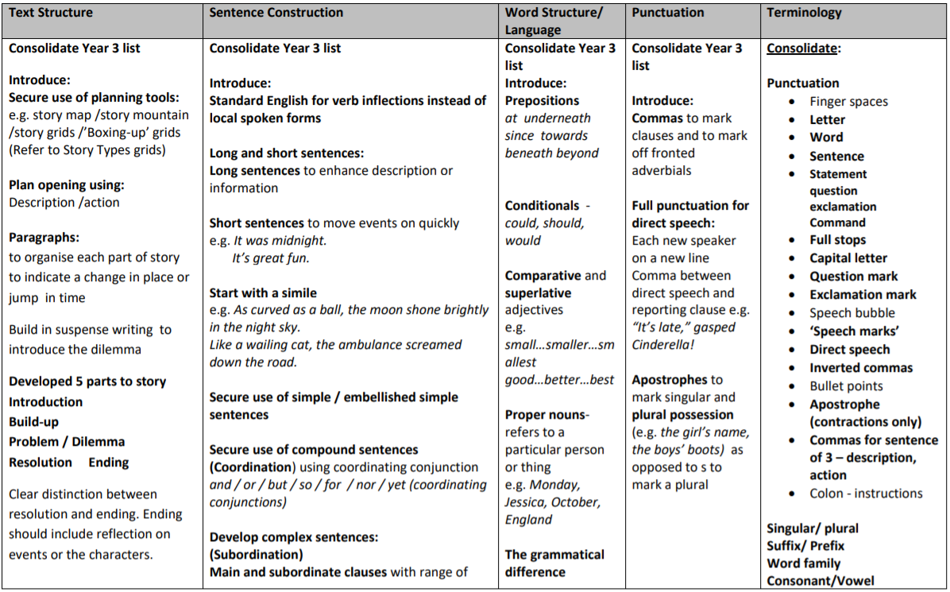
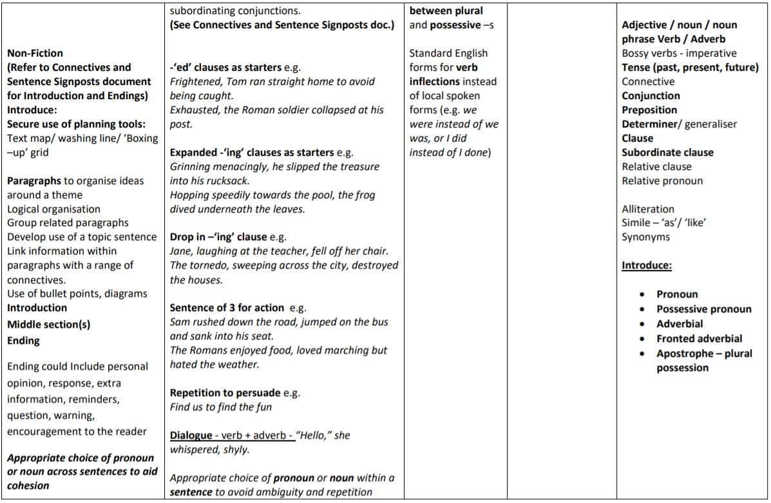
(Band 12-13 in the Birmingham language and literacy toolkit)

End of Year 4 Non-Statutory Assessment – WTS
Name: | A | B | C | D | E | F | Collection
The pupil can:
- After discussion with the teacher, the pupil can write for different purposes.
- Features of writing mainly appropriate to the selected task.
- Some use of expanded noun phrases to describe, adding relevant and meaningful detail.
- In narratives, some appropriate use of speech to convey character.
- Simple text structure with an attempt to organise related ideas into paragraphs.
- Headings and sub-headings aid presentation where appropriate.
- Some use of simple adverbials and pronouns to link sentences, sections or paragraphs.
- Variation of sentence structure through use of sentences with more than one clause.
- Some use of subordinating and co-ordinating conjunctions to join sentences with more than one clause (eg and, but, so, or, because, when, if).
- Tense choice mostly consistent and grammatically accurate including use of present perfect tense where appropriate.
- Capital letters and full stops consistently used accurately.
- Spell most common exception words.
- Segment spoken words into phonemes and represent these by graphemes, spelling most of these words correctly and making phonically-plausible attempts at others.
- Spell correctly many words from the year 3 / year 4 spelling list.
- Use the diagonal and horizontal strokes needed to join most letters.
- Spelling KS1 common exception words correctly.
- Spelling most words correctly* (year 3 / 4)
- Letters are consistent in size and proportion with both letters and words evenly spaced.
- Letters are joined using diagonal and horizontal strokes where appropriate.

(Band 13 in the Birmingham language and literacy toolkit)
End of Year 4 Non-Statutory Assessment – ‘Y5 ready’
Name: |  | A | B | C | D | E | F | Collection
The pupil can:
- Write effectively for a range of purposes
- Features of text type or genre are appropriate for task e.g. layout, verb form and formality.
- In narratives, describe settings and characters.
- Use expanded noun phrases, adverbs and adjectives for precision, clarity and impact.
- Some use of dialogue to convey character.
- Use of fronted adverbials and pronoun referencing to link within and between paragraphs.
- Variation of sentence structure through a range of openings (Fronted adverbials, subject reference and speech).
- Using a range of conjunctions (Subordinating and co-ordinating) to join sentences with more than one clause.
- Capital letters, full stops, question marks and exclamation marks consistently used accurately. (Correct sentence boundary demarcation) | Full stops
 | Capital letters
 | Question mark
 | Exclamation marks
- Apostrophes for singular and plural possession used mainly correctly.
- Inverted commas used mainly correctly.
- Commas used to mark fronted adverbials – mainly correctly.
- Using different verb forms which are mostly accurate (present and past progressive, present perfect and ing verbs.
- Spelling KS1 common exception words correctly.
- Spelling most words correctly* (year 3/4.)
- Letters are consistent in size and proportion with both letters and words evenly spaced.
- Letters are joined using diagonal and horizontal strokes where appropriate.

(Band 13-14 in the Birmingham language and literacy toolkit)
End of Year 4 Non-Statutory Assessment – Greater Depth
Name: |  | A | B | C | D | E | F | Collection
The pupil can:
- The pupil can write effectively for a range of purposes and audiences, drawing on their reading to inform the vocabulary and grammar of their writing
- Distinguish between the language of speech and writing
- Language choices demonstrate some awareness of audience in terms of formality and/or informality.
- Use the range of punctuation taught, correctly. | Full stops
 | Capital letters
 | Exclamation mark
 | Question mark
 | Apostrophes for singular and plural possession
 | Inverted commas
 | Commas used to mark fronted adverbials and in a list

Year 5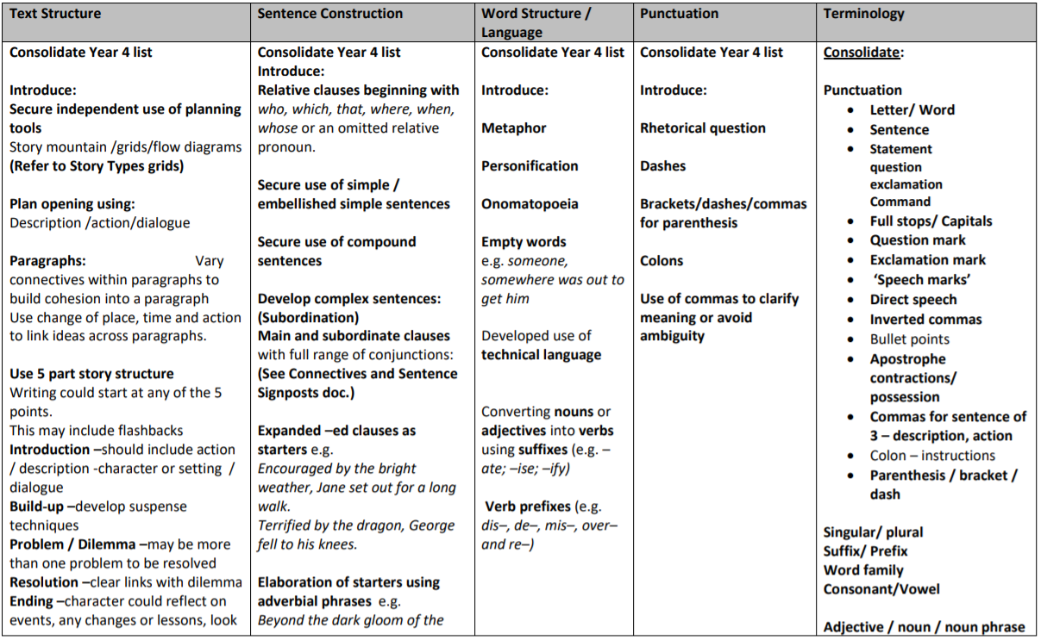
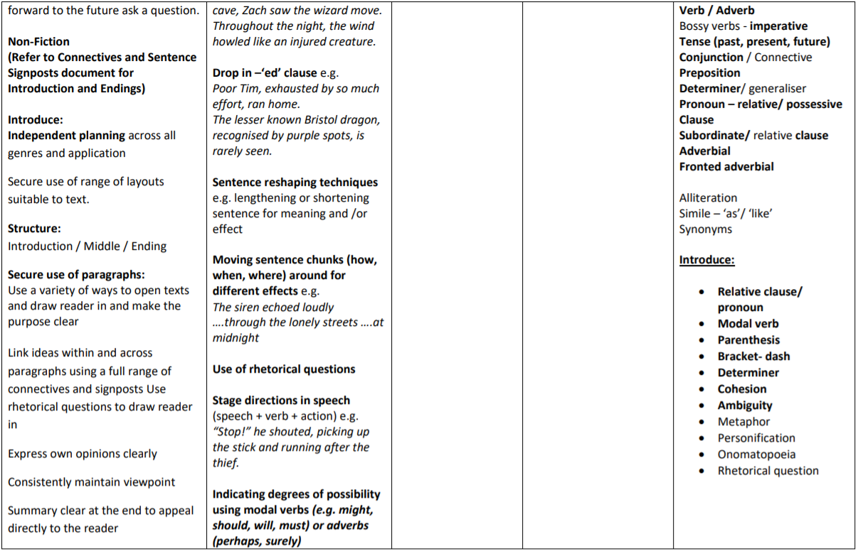

(Band 13-14 in the Birmingham language and literacy toolkit)
End of Year 5 Non-Statutory Assessment – WTS
Name: |  | A | B | C | D | E | F | Collection
The pupil can:
- The pupil can write for a range of purposes with appropriate use of scaffolds.
- Features of text type or genre are appropriate for task e.g. layout, verb form and formality.
- Some use of dialogue to convey character.
- Use paragraphs to organise ideas around a theme.
- Headings and sub-headings aid presentation where appropriate.
- Use of fronted adverbials and pronoun referencing to link within and between paragraphs.
- Variation of sentence structure through a range of openings (Fronted adverbials, subject reference and speech).
- Using a range of conjunctions (Subordinating and co-ordinating) to join sentences with more than one clause.
- Using different verb forms which are mostly accurate (present and past progressive, present perfect and ing verbs).
- Use capital letters, full stops, question marks, commas for lists and apostrophes for contraction mainly correctly. | Capital letters
 | Full stops
 | Question marks
 | Commas for lists
 | Apostrophes for contraction
- Spell most common exception words.
- Spell correctly many words from the year 3 / year 4 spelling list, and some words from the year 5 / year 6 spelling list.
- Letters are joined using diagonal and horizontal strokes where appropriate.

End of Year 5 Non-Statutory Assessment – ‘Y6 Ready’
Name: |  | A | B | C | D | E | F | Collection
The pupil can:
- Write for a range of purposes and audiences.
- Some evidence of selecting vocabulary and grammatical structures that reflect what the writing requires (e.g. using contracted forms in dialogue in narrative; using passive verbs to affect how information is presented; using modal verbs to suggest degrees of possibility).
- In narratives, describe settings, characters and atmosphere.
- Some use of adverbs, preposition phrases and expanded noun phrases effectively to add detail, qualification and precision.
- Integrate dialogue in narratives to convey character and/or advance action.
- Using some cohesive devices, including use of adverbials (time, place and number), within and across sentences and paragraphs.
- Use of complex structures including the use of relative clauses. Sentence structures are varied throughout text.
- Using a wider range of conjunctions (Subordinating and co-ordinating) to join sentences with more than one clause.
- Verb forms used accurately and appropriate tense choice maintained including use of modal verbs.
- Use the full range of punctuation taught in lower KS2 mostly correctly | Full stops
 | Capital letters
 | Exclamation mark
 | Question mark
 | Apostrophes for singular and plural possession
 | Inverted commas
 | Commas used to mark fronted adverbials and in a list
- Inverted commas used mostly correctly.
- Some correct use of punctuation for parenthesis.
- Commas (clarify meaning and marking phrases and clauses).
- Apostrophes for singular and plural possession used mostly correctly.
- Spelling KS1 common exception words correctly.
- Spelling many words correctly* (year 5/6).
- Maintain legibility, fluency and speed in handwriting through choosing whether or not to join specific letters.
(Band 14 in the Birmingham language and literacy toolkit)

(Band 14-15 in the Birmingham language and literacy toolkit)
End of Year 5 Non-Statutory Assessment – Greater Depth
Name: |  | A | B | C | D | E | F | Collection
The pupil can:
- Write effectively for a range of purposes and audiences selecting language that shows good awareness of the reader (e.g. first person in a diary; direct address in instructions and personal writing.)
- Distinguish between the language of speech and writing and sometimes choose the appropriate register.
- Writing shows some awareness of levels of formality although this may not be well managed.
- Use the range of punctuation taught, correctly. | Full stops
 | Capital letters
 | Exclamation mark
 | Question mark
 | Apostrophes for singular and plural possession
 | Inverted commas
 | Commas (clarify meaning and marking phrases and clauses)
 | Punctuation for parenthesis () - ,

Year 6 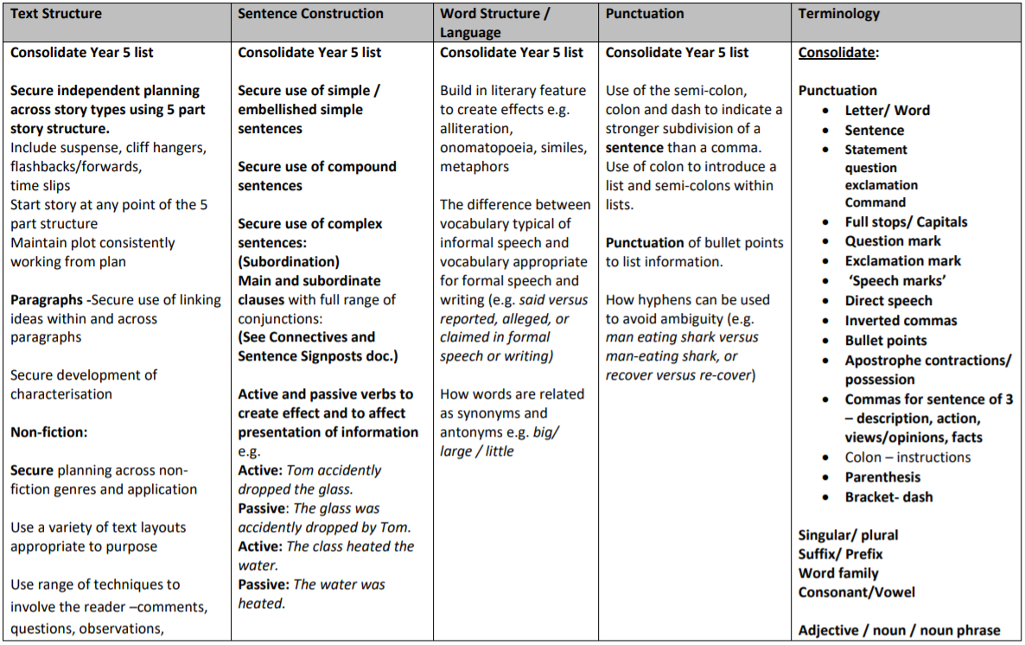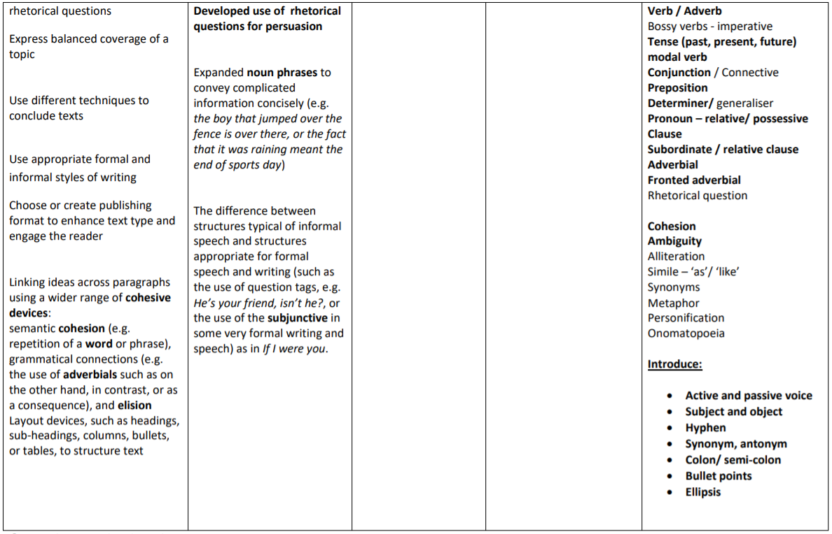
(Band 15 in the Birmingham language and literacy toolkit)
End of key stage 2 statutory assessment – working towards the expected standard
Name: | A | B | C | D | E | F | Collection
The pupil can:
- write for a range of purposes
- use paragraphs to organise ideas
- in narratives, describe settings and characters
- in non-narrative writing, use simple devices to structure the writing and support the reader (e.g. heading, sub-headings, bullet points)
- use capital letters, full stops, question marks, commas for lists and apostrophes for contraction mostly correctly
- spell correctly most words from the year 3 / year 4 spelling list, and some words from the year 5 / year 6 spelling list
- write legibly

(Band 15-16 in the Birmingham language and literacy toolkit)
End of key stage 2 statutory assessment – working at the expected standard
Name: | A | B | C | D | E | F | Collection
The pupil can:
- write effectively for a range of purposes and audiences, selecting language that shows good awareness of the reader (e.g. the use of the first person in a diary; direct
address in instructions and persuasive writing)
- in narratives, describe settings, characters and atmosphere
- integrate dialogue in narratives to convey character and advance the action
- select vocabulary and grammatical structures that reflect what the writing requires, doing this mostly appropriately (e.g. using contracted forms in dialogues in narrative; using passive verbs to affect how information is presented;
using modal verbs to suggest degrees of possibility)
- use a range of devices to build cohesion (e.g. conjunctions, adverbials of time and place, pronouns and synonyms) within and across paragraphs
- use verb tenses consistently and correctly throughout their writing
- use the range of punctuation taught at key stage 2 mostly correctly (e.g. inverted commas and other punctuation to indicate direct speech)
- spell correctly most words from the year 5 year 6 spelling list, and use a dictionary to check the spelling of
uncommon or more ambitious vocabulary
- maintain legibility in handwriting when writing at speed

(Band 16 in the Birmingham language and literacy toolkit)
End of key stage 2 statutory assessment – working at greater depth within the expected standard
Name: | A | B | C | D | E | F | Collection
The pupil can:
- write effectively for a range of purposes and audiences, selecting the appropriate form and drawing independently on what they have read as models for their own writing (e.g. literary languages, characterisation, structure)
- distinguish between the language of speech and writing and choose the appropriate register
- exercise an assured and conscious control over levels of formality, particularly through manipulating grammar and vocabulary to achieve this
- use the range of punctuation taught at key stage 2 accurately, (e.g. semi-colons, dashes, colons and hyphens) and, when necessary, use such punctuation precisely to enhance meaning and avoid ambiguity

