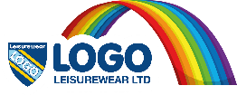
Returns Form
All items returned to us must be in a saleable condition.

Child / Customer Name:
Contact Number/Email Address:
School: |  | Class:
Order ID Number:

I am returning the following items:
Item | Date of Purchase | Colour | Size | Quantity

I am returning these items because:
Wrong Size or Colour ordered  (tick box) | Wrong Size or Colour received  (tick box) | Faulty-  Please State | Any other reason –  Please State

I would like to exchange these items for:
Item | Colour | Size | Quantity

I have included difference due to different garment exchange £________

Alternatively

I would like a refund, online orders only. ID Number needed
(please tick)

Credit note for non online orders (please tick)

Please ensure all the correct information is stated above before returning this form and garments to the school office or directly to Logo Leisurewear.

